

MILESTONE ACADEMY
KHAPRI, DURG, C.G.

PROJECT
INFORMATION TECHNOLOGY
CODE : 402
SESSION : 2025-26
SUBMITTED BY: Gajendra Kumar Sahu SUBMITTED TO:
STUDENT NAME : Gajendra Kumar Sahu Miss. Anju Mam
ROLL NO. : 29
CLASS & SECTION : 10C

Pg 1
ACKNOWLEDGEMENT

I wish to express my deep sense of gratitude and indebtedness to our learned teacher Miss. Anju Mam, TGT – Computer Science, Milestone Academy for her invaluable help, advice and guidance in the preparation of this project.
I am also greatly indebted to our principal Miss. Saroj Mam and school authorities for providing me with the facilities and requisite laboratory conditions for making this practical file.
I also extend my thanks to my classmates and friends who helped me to complete this practical file successfully.

Gajendra Kumar Sahu

Pg 2

CERTIFICATE

This is to certify that I am Gajendra Kumar Sahu of class 10 has successfully completed the Information Technology - 402 project on the topic “School Management System” under the guidance of Miss. Anju Mam during the academic year 2025-26.

Internal Examiner Principal
Signature Seal and Signature

Pg 3

INDEX

Sr. No. | Particulars | Page No. | Signature | Remarks
1 | Introduction | 4
2 | Objectives | 5
3 | Software and Hardware Requirement Specification | 6
4 | System Design | 7
5 | Conclusion
6 | Bibliography and References

Pg 4

INTRODUCTION

The “School Management Project” is designed to simplify and organize the various activities and operations of a school. This project focuses on creating a system that helps manage essential school data such as student records, teacher information, class schedules, and examination details.

In most schools, managing this data manually can be time-consuming and prone to errors. By using a digital system, we can make the process faster, more efficient, and accurate.

This project gives a basic idea of how technology can be used in education to manage day-to-day operations. It also helps in understanding the role of databases and user interfaces in real-life applications.

Pg 5

Objective of School Management Project

The main objective of the School Management Project is to develop a simple and efficient system that can help manage school-related data in an organized way. This includes:
- Maintaining accurate records of students, teachers, and staff
- Managing class schedules and subjects
- Storing examination and result details
- Reducing paperwork and manual errors
- Making the school’s administrative work faster and more reliable

This project aims to show how digital tools can improve the overall functioning of a school by saving time and improving accuracy.

Pg 6

HARDWARE AND SOFTWARE REQUIREMENTS

1. Processor: Dual Core or Above
2. Motherboard: CHIPSET FOR AMD ATHALON
3. RAM: 2GB+
4. Hard disk: SATA 100 GB OR ABOVE
5. Monitor: 14.1 or 15 -17 inch

SOFTWARE REQUIREMENTS:
1. Windows OS
2. OpenOffice.org 3.2
3. MS office

Pg 7

This project consists of three parts:

- Digital Documentation (Unit 1): Create a documentation file in OpenOffice writer that contains the system overview, user instructions, and reports.

- Spreadsheet (Unit 2): Use OpenOffice calc to manage student data, grade sheets, and performance analysis.

- Database (Unit 3): Use Database to store and manage student records, courses, and performance data.

Pg 8
Part 1: Digital Documentation (Unit 1)
Project Overview:
- Create a new document in MS Word titled “School Management System”.
- Provide an introduction to the project and explain the purpose of the system (manage student details, grades, and other academic data).
- Include features like student record management, performance analysis, and report generation.

Procedure:
- Open OpenOffice Writer and select a Blank Document.
- Format the font style to “Candara Light”, font size 12.
- Type “School Management System” at the top of the page, format Bold, set font size to 18-20, and align it to the center.
- Press Enter and type “Project Overview” as a heading. Make it Bold and set font size to 14-16.
- Then, write an introduction explaining “Project’s Objective”.
- Repeat steps 3 to 4 for “Project’s Purpose”
- Use bullet points for detailing.
- Press Ctrl + Alt + S and type “School Management Project”.

Pg 9
Part 2: Spreadsheet (Unit 2)

- Create students Workbook in OpenOffice calc:
Open spreadsheet and create a new workbook called “Student Database”.
Q1 Create a “Student Information Sheet” with columns such as:
- Student ID
- Name
- Date of Birth
- Class
- Marks
2. Create “Grade Calculation” :
- Create columns for each subject with marks (e.g., Maths, Science, English).
- Use formulas to calculate the “Total Marks” , “Average” for each student.
- Add a “Grade” column based on the average score (for example: A for 90-100, B for 75-89, C for 60-74, and so on).
Example Formula:
- Total Marks Formula: `=SUM(B2:E2)`
- Average Marks Formula: `=AVERAGE(B2:E2)`
- Grade Formula:
- =IF(F2>=90,"A",IF(F2>=75,"B",IF(F2>=60,"C",IF(F2>=50,"D","F"))))

3. “Performance Analysis:”
* Create a separate sheet that summarizes the overall performance:
* “Highest Marks” in each subject.
* “Class Average” in each subject.
4. Graphs/Charts:
- * Add charts like “Bar Chart” or “Pie Chart” to visualize the distribution of grades, subject-wise performance, and class averages.

Pg 10
Procedure:
Part-A: Student Information
- Open OpenOffice Calc and select a Blank Spreadsheet.
- Click Ctrl + Alt + S and name the file "Student Database".
- In the first sheet, rename Sheet as “Student Information Sheet”.
- In the first row, enter the column headings as follows:
“Student ID”, “Name”, “Date of Birth”, “Class”, “Marks”
- Format the heading row by making the text Bold and increasing the column width for better visibility.
- Enter sample student data in the rows below the headings.
- Set the Date of Birth column format to Date using Format Cells.
- Align the data properly and apply borders if required for a neat appearance.
- Review the entered information for accuracy.
- Click on File Save to save the Student Information

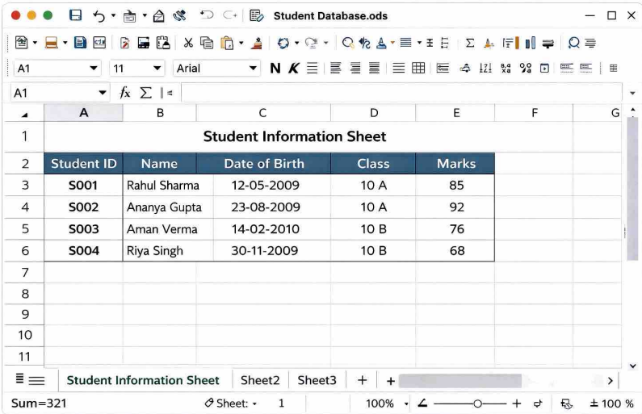

Pg 11
Part-B: Grade Calculation Sheet

- Open the Student Database workbook in OpenOffice Calc.
- Insert a new worksheet and rename it as Grade Calculation.
- In the first row, enter column headings such as “Student ID”, “Name”, “Maths”, “Science”, “English”, “Total Marks”, “Average”, “Grade”.
- Enter marks for each subject for all students in the respective columns.
- To calculate Total Marks, click on the first cell under the Total Marks column and enter the formula: =SUM(C2:E2)
- Press Enter and use the Fill Handle to copy the formula for other students.
- To calculate Average Marks, enter the formula in the Average column: =AVERAGE(C2:E2)
- Copy the average formula to the remaining rows using the Fill Handle. To calculate Grade, enter the following formula in the Grade column:
IF(F2>=90, “A”,IF(F2>=75, “B”, IF(F2>=60,”C”, IF(F2>=50,”D”,”F”))))
- Apply the grade formula to all students by dragging the Fill Handle.
- Format the heading row by making it Bold and adjust column width for clarity.
- Save the worksheet by clicking File Save.

Pg 12

Part-C: Performance Analysis
- Open OpenOffice Calc / MS Excel and select a Blank Spreadsheet.
- Save the file by clicking File → Save As and name it Student Performance Sheet.
- In the first row, enter column headings such as Roll No, Student Name, Class, Subject, Marks Obtained, Total Marks, Percentage, Grade.
- Enter sample student data below the headings for at least 5-10 students.
- To calculate Percentage, use a formula like:
=(Marks Obtained / Total Marks) * 100
- Apply the formula to all students using the Fill Handle.
Pg 13
- Assign Grades using conditions (e.g., A, B, C) based on percentage.
- Select the data and apply Bold formatting to headings for better presentation.
- Use AutoSum to calculate total marks if required.
- Create a Bar Chart or Column Chart to show student performance using Insert → Chart.
- Label the chart properly with Title, X-axis, and Y-axis.
- Save the spreadsheet after completing the data entry and analysis.

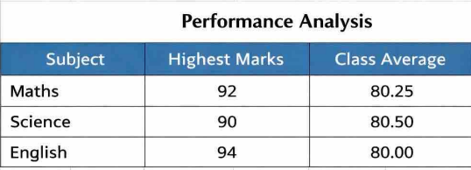

Pg 14
Part 3: Database (Unit 3)
- Create a new database in Database called **“School Management System”**.
- Set up the following tables:

1 Create “Students” Table in Wizard view: For storing basic student information.
( insert 10 records).
* Fields: **Student ID**, **Name**, **DOB**, **Class**, **Gender**, etc.
2 “Subjects “Table in Design view : To store the list of subjects offered by the school.
( insert 7 records).
* Fields: **Subject ID**, **Subject Name**, **Teacher Name**.
3 “Marks Table”: To store the student’s marks for each subject.
* Fields: **Student ID**, **Subject ID**, **Marks**, **Exam Date**.
( insert 5 records)
- Create relationships between the tables to connect them. For example:

1 **Students Table** → **Marks Table** (one-to-many relationship).
2 **Subjects Table** → **Marks Table** (one-to-many relationship).

3. **Queries:**
* Create queries (in Design view) to perform tasks like:
* “Display Student records get grade A”:
4. **Forms:**

* Create forms for data entry (adding students, adding marks, etc.).

* Example: A form to enter new student information, including name, class, and subjects enrolled.

5. **Reports:**

* Create **Reports** in database to generate:
* “Student Report Card” (marks, grades, subject performance).
- * “Class Summary Report” showing the average marks, highest marks, and top students.
Pg 14
Procedure:

Steps to Create "Students" Table in Database

- Open OpenOffice Base (Database application).
- Click on Create a new database and then click Next.
- Choose Yes, register the database and click Finish.
- Save the database with the name School Management System.
- In the Database window, click on Tables from the left panel.
- Select Create Table Using Wizard.
- Choose appropriate fields and add the following fields to the table:
- Student ID, Name, DOB, Class, Gender. Set suitable data types for each field (Number for
- Student ID, Text for Name and Class, Date for DOB). Set Student ID as the Primary Key.
- Click Next and name the table as Students. Click Finish to create the table.
- Open the Students table in Datasheet View and insert 10 student records.
- Save the table after entering the records.

Pg 15
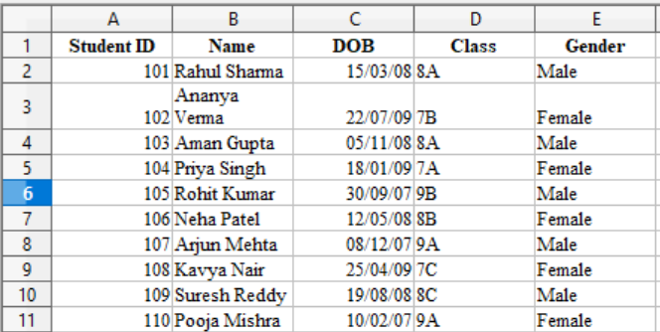

Queries in Database (Design View)

- Open OpenOffice Base and open the database School Management System.
- In the Database window, click on Queries from the left panel. Select Create Query in Design View.
- Add the required table(s) (such as Students or marks table) to the query window and click Close.
- Drag the required fields like Student ID, Name, Class, Marks, Grade into the query grid.
- In the Criteria row under the Grade field, type "A" to display students who scored Grade A.
- Ensure the Show checkbox is selected for all required fields.

Pg 16
- Click on Run Query to view the result showing students with Grade A.
- Save the query by clicking File → Save.
Name the query as Grade A Students and click
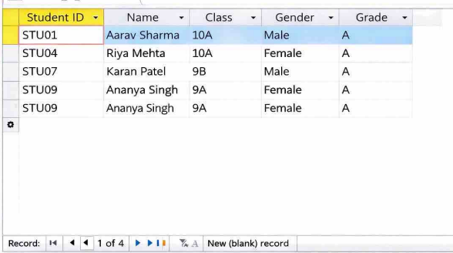
- OpenOffice Base and open the database School Management System.
- In the Database window, click on Forms from the left
- panel. Select Use Wizard to Create Form.
- Choose the table Students (or relevant table) from the list.
- Move required fields such as Student ID, Name, DOB, Class, Gender to the selected Open fields section.
Pg 17

- Click Next and choose the arrangement of controls (Columnar layout).
- Click Next and select the default data entry mode.
- Click Next and choose a suitable form style.
- Click Next, give the form a name like Student Entry Form, and select Modify the Form if required.
- Click Finish to create the form.
- Use the form to add new student information such as name, class, and subjects enrolled.
- Save and close the form after data entry.

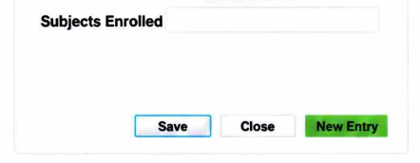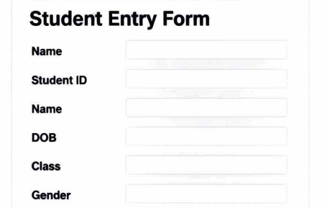
Pg 18
Reports in Database
- Open OpenOffice Base and open the database School Management System.
- In the Database window, click on Reports from the left panel.
- Select Use Wizard to Create Report.
- Choose the required table or query (such as Students, Grade A Students, or marks table).
- Move the required fields such as Student Name, Class,
- Subject, Marks, Grade to the selected fields section. Click Next and arrange fields in the desired order.
- Choose grouping options if required (for example, group by Class or Subject).
- Select sorting options such as Marks (Descending) to show top students.
- Click Next and choose the report layout and orientation.
- Give the report a suitable name such as Student Report Card or Class Summary Report.
- Click Finish to generate the report.
- View, save, and print the report if required.

Pg 15
Conclusion
In conclusion, the “School Management Project” helps in understanding how technology can be used to manage school operations more effectively. By creating a system that stores and organizes data about students, teachers, classes, and exams, we can reduce manual work, save time, and minimize errors.
This project has improved our knowledge of how digital systems are used in real-life situations, especially in the field of education. It also gave us hands-on experience in planning, designing, and organizing data in a structured way.
Overall, this project shows the importance of digital solutions in improving school management and making administrative tasks easier and more efficient.

References
1. CBSE Study Material
2. Text book : Sumita Arora
3. www.openoffice.org

